Project Design Phase-II Technology Stack (Architecture & Stack)

|  |  |
| --- | --- |
| Date | 03 October 2022 |
| Team ID | PNT2022TMID49866 |
| Project Name | Digital Naturalist-AI enabled tool for biodiversity researches |
| Maximum Marks | 4 Marks |

**Technical Architecture:**

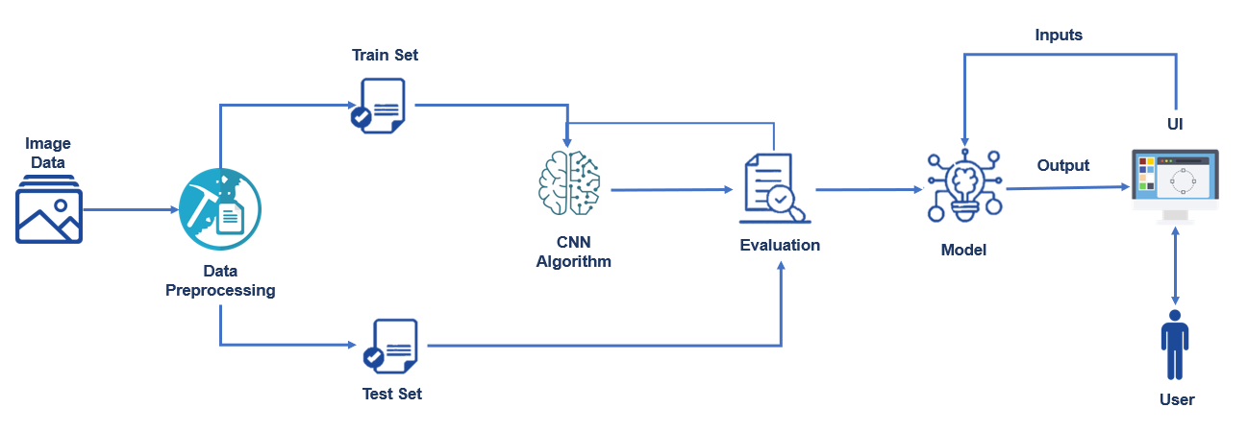

Table-1: Components & Technologies:

|  |  |  |  |
| --- | --- | --- | --- |
| **S. No** | **Component** | **Description** | **Technology** |
| 1. | User Interface | How user interacts with application | HTML, CSS, JavaScript |
| 2. | Application Logic-1 | Pre-processing the model using datasets | Python |
| 3. | Application Logic-2 | Image processing | CNN (Convolutional Neural Networks) |
| 4. | Application Logic-3 | Object detection | Deep Learning |
| 5. | Database | Data Type, Configurations etc. | MySQL, NoSQL, etc. |
| 6. | Cloud Database | Database Service on Cloud | IBM DB2, IBM Cloud etc. |
| 7. | File Storage | File storage requirements | IBM Block Storage or Other Storage Service or Local Filesystem |
| 8. | External API-1 | Image recognition | IBM Watson Visual Recognition |
| 9. | Deep Learning Model | Purpose of Deep Learning Model | Object Recognition Model, YOLOv3 etc. |
| 10. | Infrastructure (Server / Cloud) | Application Deployment on Local System / Cloud  Local Server Configuration: Cloud Server Configuration: | Local, Cloud Foundry etc. |

Table-2: Application Characteristics:

|  |  |  |  |
| --- | --- | --- | --- |
| **S. No** | **Characteristics** | **Description** | **Technology** |
| 1. | Open-Source Frameworks | Flask (Web framework) | Python |
| 2. | Security Implementations | Drowning detection by the camera | AI (Artificial Intelligence) |
| 3. | Scalable Architecture | 3 – tier architecture | Python |
| 4. | Availability | All the time when the persons are under surveillance | AI (Artificial Intelligence) |
| 5. | Performance | Detection of drowning person within 5 – 15 seconds | CNN (Convolutional Neural Networks) |